Andrew Botsford
Andrewbotsford45@hotmail.com / 07885 976023
TMA1
Andrew Botsford
(Submitted 1st June 2023)
Essay, 4x TiMs, & Proof of TGF Activity
Contents
ESSAY 2
TiMs 8
Unit 1, Session 2, Activity 2.7 9
Unit 1, Session 3, Activity 3.10 10
Unit 1, Session 4, Activity 4.7 11
Unit 1, Session 5, Activity 5.7 12
References (TiMs) 12
Participation in the TGF 14

ESSAY

How far do representations of organisational culture reflect the realities of everyday organisational life?
Overview
This essay considers the culture of INPEX, who the author works for, and Patagonia. Outline statistics and the logo of each company can be seen in Figure 1. Luhman and Cunliffe (2013) define organisational culture as “the set of beliefs, values, assumptions, norms, stories, ceremonies, artefacts, and symbols within an organisation that influence the way employees behave and perform their jobs”. Observations of some of these items have been incorporated into analytical methods introduced in Unit 1 of B870 to illustrate the respective cultures of each organisation (Figure 2, Figure 3 & Figure 4).
The cultural context of each company varies in relation to their industry:
- INPEX operates safety critical offshore projects and sells products to a limited number of wholesale energy purchasers. It therefore makes sense for rules and procedures to be implemented widely to prevent employees engaging in unpredictable behaviour in safety critical environments. In some cases, these procedures may waste time and prevent employees focussing on other objectives which could be more productive. Creating a cultural image is less important than if they were selling to a wider audience.
- Patagonia design and manufacture clothing with a strong sustainability ethos and directly sell to customers globally (including their employees). Standardising culture across the group by selecting employees based on their lifestyle will help promote the company’s brand. Whilst this idea makes good snippets for Youtube promotional videos it doesn’t reflect the reality of having to operate stores and work trading hours. Therefore, although cultural control is preferred by Patagonia it is inevitable that forms of direct control will emerge.
Although both companies are in different industries there are lessons to be learned from each including the safety focus of INPEX and the marketing style of Patagonia.

 | INPEX | Patagonia
Founded | 1941 | 1973
Headquarters | Japan | USA
Industry | Energy (Oil & Gas) | Clothing
Number of Employees | 1,001-5,000 employees | 1,001-5,000 employees
Revenue | $16 Bn (INPEX, 2023) | $1.5 Bn (Balch, 2023)
Figure 1: Basic Information on the two companies considered in this essay.
Culture and Observations
Figure 2 shows an interpretation of culture for both companies based on a theoretical framework proposed by du Gay et al (1997). Cultural practices are defined in this analysis as follows:
- The respective company homepages show how the companies represent themselves.
  - INPEX represent themselves on their homepage with a snapshot of their activities and a message from the CEO stating the objective of supplying energy. Patagonia represent themselves with an image of the ocean and a message to viewers to protect it.
- Identity is linked to how the company sees itself in the world and interprets its purpose.
  - INPEX see themselves as a reliable supplier of energy. Patagonia sees itself as a company providing sustainable clothing and they link this to an overarching mission to save the world.
- Production is what the company makes and sells.
  - Simply INPEX make hydrocarbons, energy, and their products and Patagonia make clothes. In addition both companies create messages responding to and shaping the world around them.
- Consumption is how its products are received and used by customers.
  - INPEX products are directly consumed by a minority of buyers, but derivatives are consumed by almost everyone. Patagonia directly sell to many more individual customers.
- Regulation is how society (and the company) see its operations and activities, this will affect sales and its license to operate.
  - If the public have a negative impression of INPEX it may harm their ability to attract investors but people still need to use energy and most don’t have a say in where it ultimately comes from. If the general public have a negative impression of Patagonia (ie poor quality clothes, unethical suppliers) they would be less likely to buy clothes and this would have a big impact on the business.
The culture of each company permeates through the articulations of the practices defined above. INPEX and Patagonia have many differences in the products they make and the number of people who they directly interact with. Patagonia present themselves as something more than a clothes supplier as they are trying to save the world, by comparison INPEX are merely aiming to provide a stable and efficient supply of energy.
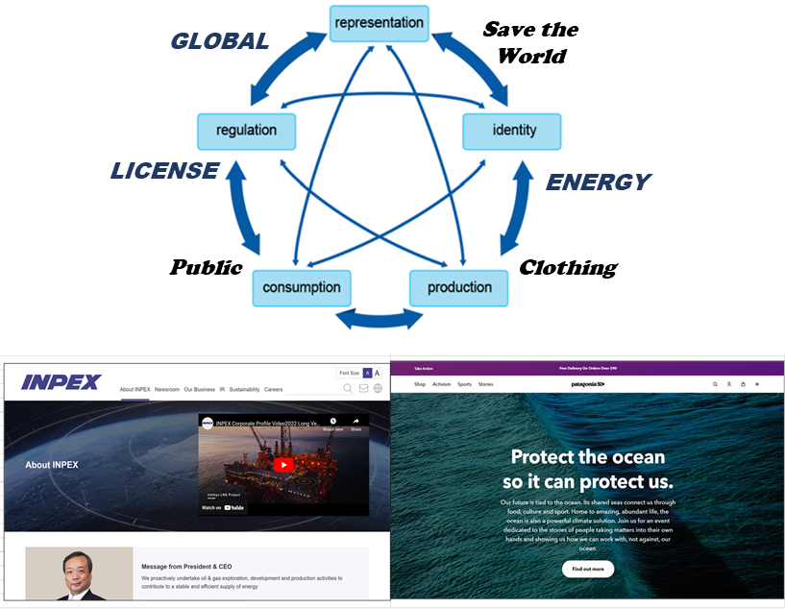
Figure 2: Application of the circuit of culture (Du Gay et al, 1997) to INPEX and Patagonia.
Figure 3 presents illustrations of cultural levels within INPEX and Patagonia using an approach introduced by Schein (1997). Cultural levels have been interpreted as follows:
- Artefacts of INPEX include oil rigs, tanker ships, large computers, formal meeting rooms. Business agreements are often signified by signing ceremonies with high-ranking government officials. The company logo is simple and related to the English international representation of the company.
- Artefacts of Patagonia include their products (clothes), advertisements (especially pictures of landscapes), shop floors, and generally bright colours. The company logo sometimes integrates the mountain landscape.
- Offices and clothes are generally formal at INPEX, within Patagonia most staff in videos are wearing less formal clothes.
- INPEX values are diversity, integrity, ingenuity, safety and collaboration. Patagonia values are quality, integrity, environmentalism, justice, and not to be bound by convention.
  - The level to which corporate values are adopted by all the stakeholders within a company is certain to be variable.
- Deep basic assumptions within the company are linked to time keeping and more formal clothes at INPEX and to family first attitudes and casual clothes at Patagonia.
These ideas create a feel for the culture within the organisations and may suggest Patagonia culture can be defined as more relaxed than that within INPEX, although this will depend on the context.
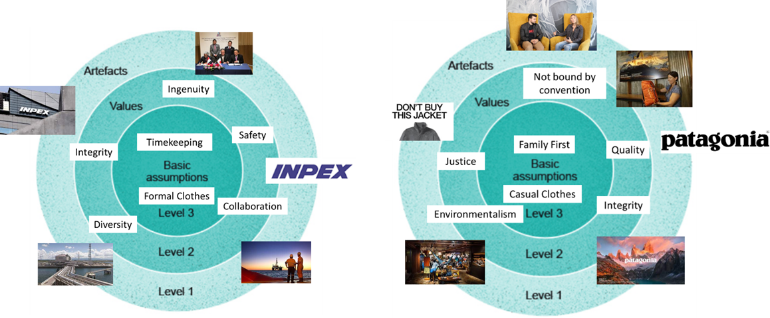
Figure 3: Illustrations of levels of culture for INPEX and Patagonia using the framework introduced by Schein (1997).
Subcultures
Figure 4 shows some potential sub-cultures within INPEX and Patagonia, based on their organisation charts and a view from adverts and videos. Both organisations seem to have diverse differentiated subcultures from the perspective of a top-down look at the entire organisation.
- Both companies have strong links to their home countries and regions and these cultures are notable in the representations of the companies in the INPEX CEO and most Patagonia staff within Youtube videos.
- The companies differ in the way they attempt to build the company culture. Patagonia openly state that they select staff based on their lifestyle and whether they fit their ethos, whereas INPEX do not state that they select staff based on these characteristics (although they may do in reality).
  - INPEX require highly trained technical staff and cannot be very selective in some disciplines as there are shortages.

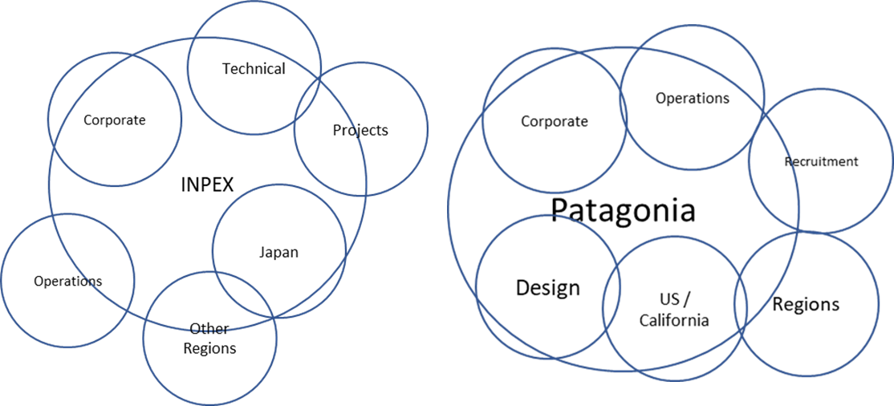
Figure 4: Illustrations of highly generalised subcultures within INPEX and Patagonia in a style introduced by Martin (1992).
Management and Control
Knights & Willmott’s (2012) framework of control has been used to understand the methods of applying power within the two organisations (Figure 5).
INPEX control is linked to rules and procedures more than those at Patagonia. Patagonia strongly identifies with a culture than can be defined as environmental, and this will control the behaviours of staff when it comes to making decisions such as selecting suppliers. Cultural control is also applicable to ideas such as an onsite creche and creating an environment where parents are happy to bring children into meetings.
Direct control has been experienced at INPEX through performance management systems and the requirement to meet deadlines, as well as attending the office during certain hours. Forms of direct control at Patagonia are less obvious but one job advert in event management states 30% of work will include travel including nights and weekends. It is also likely that deadlines and defined working hours are commonplace within certain parts of the organisation.
Figure 5: Subdivision of aspects of INPEX and Patagonia and a classification within the Knights & Willmott (2012) framework of control.
Discussion
The forms of control could be considered as more of a reality for life within the two companies as they are based on job adverts, quotes, and personal experience. The cultural interpretations shown above are based on adverts and websites so are linked to representation.
The culture of INPEX shows complex engineering, political agreements, and an identity as an energy supplier. They assume the world needs and wants energy and take pride in providing it. The companies’ control is through many methods, but rules and procedures dominate. This reality of control fits the representation of its culture well. The company doesn’t make any statements beyond its core purpose and only needs to represent itself as a reliable operator.
Patagonia make statements beyond their core purpose, representations which may not be fully implemented in every aspect of their day-to-day practice. The culture of Patagonia shows mountainous scenery, casual clothes, an outdoors lifestyle, and the identity that they want to save the world. This assumes that the world needs saving. The dominant control method noted is through culture which may be expected in a company looking to save the world, however there are examples of direct control of office hours and the need to travel. There are office roles within the company that could be comparable to any other company in the world.
Direct control implies a mild form of exploitation as workers are being asked to do something their employers do not want to do but they can afford to pay someone to do. The founder of Patagonia, Yvon Chouinard, is said to have a net worth of $1.2bn (Balch, 2023). From this perspective any form of direct control contrasts with the Patagonia value of justice as enforcing behaviour on someone is an unjust action. It is also notable that 13% of the polyester it uses comes from virgin petroleum (Balch, 2023), this could also be viewed as at odds with its environmentalism value as it is using unsustainable and potentially polluting materials. It makes sense for Patagonia to promote a sustainable mission as it is honourable and helps them sell clothes, but they should be careful not to make representations they are unable to realise or they could be seen to lack sincerity.
More thoughtful ways of organising
By examining the cultures of INPEX and Patagonia, representations of culture have been unpacked and compared with how the companies control their staff. The process of reviewing the companies in this way necessitates viewing them from different perspectives which allows new insights and understanding of the organisations. By comparing organisations, it is possible to take ideas applied in one and apply in another, for example INPEX could implement a creche for staff or Patagonia could implement a safety moment in meetings. Patagonia are setting an example in driving sustainability which should be applauded even if it is motivated by a desire to enhance their business.
References
Balch, O. (2023) “Ryan Gellert: ‘At Patagonia we have to be greener than green – and make a profit’”, Reuters (Online), 11 April, Available at: https://www.reuters.com/business/sustainable-business/ryan-gellert-patagonia-we-have-be-greener-than-green-make-profit-2023-04-11/ (Accessed: 1 June 2023)
du Gay, P., Hall, S., Janes, L., Mackay, H. and Negus, K. (1997) Doing cultural studies: the story of the Sony Walkman. London: SAGE.
Glassdoor (2023), ‘INPEX – Employee Review’, 2 June, Available at: https://www.glassdoor.co.uk/Overview/Working-at-INPEX-EI_IE40739.11,16.htm (Accessed: 2 June 2023)
Glassdoor (2023), ‘Patagonia – Employee Review’, 2 June, Available at: https://www.glassdoor.co.uk/Reviews/Employee-Review-Patagonia-RVW62190457.htm (Accessed: 2 June 2023)
INPEX (2023), ‘Financial Results for the year ended December 31, 2022’, 10 Feb, Available at: https://www.inpex.co.jp/english/ir/library/pdf/presentation/e-Presentation20230210-a.pdf (Accessed: 1 June 2023)
Knights, D. and Willmott, H. (2012) Introducing organization behaviour and management. 2nd edn. London: Cengage Thomson Learning.
Luhman, J.T. and Cunliffe, A.L. (2013) Key concepts in organization theory. London: SAGE.
Martin, J. (1992) Cultures in organizations: three perspectives. Oxford: Oxford University Press.
Schein, E. (1997) Organizational culture and leadership. San Francisco: Jossey-Bass.

TiMs

Unit 1, Session 2, Activity 2.7
This clip shows directly controlled (Knights and Willmott, 2012) workers being exploited. The idea that they are directly controlled is demonstrated by the language used by the manager, pushing them to work harder, and by his assumption that offering a £1 bonus (~£14.20 in today’s money) will increase the productivity of the workers. The assumption that a financial incentive is primary motivation for workers can be linked to Taylor (1911) who discovered standard time for completing tasks could be beaten through means of improved remuneration.
The manager's office is above the workers, giving him a clear view of operations when he looks down on them. The Hawthorne Studies (Wren and Bedeian, 2009) found productivity of workers increased when they were being assessed which would suggest that the factory style could extract maximum productivity from workers.
Workers seem to be enthusiastic about working, it may be due to the fact they are undertaking a different task to normal (not splitting peanut shells) and feeling a shared sense of camaraderie in the search for the ticket in the way job variation was reported by Trist and Bamforth (1951) as having improved the morale of coal miners. However the theory may not be entirely applicable as workers still have low autonomy and their jubilance could only be linked to the ticket discovery.

https://youtu.be/YI5Tylind9E
From 0:00 to 01:52 (duration 1 minute and 52 seconds)

Unit 1, Session 3, Activity 3.10
A strong emphasis is placed on the need for people with ambition and smart ideas, a theme linked to the term “entrepreneurial man” of Gill (2013). In this video there is a diverse range of people (male and female) so the gendered man isn’t entirely applicable, on the other hand it is fair to say there is an over representation of men in the industry which would support the argument by Gill to gender the archetype.
Society is driving the need to develop low carbon energy and the video appeals to this discourse, by highlighting the possibility of helping to protect the world’s future and embracing the idea of global citizenship combined with entrepreneurialism noted by Butcher (2016). The idea that working on renewable energy is helping to deliver a sustainable future allows participants to justify profit making activities. The idea of entrepreneurial citizenship assumes a shared desire to improve the world whilst making profit, but the construction of wind farms and production of fossil fuels doesn’t unanimously fit this description despite what its protagonists may convince themselves.
This video appeals to younger people trying to decide on a future career path by making work in the energy industry sound important and exciting. The realities of many of the roles discussed will include less autonomy than may be suggested, and some of the work will be much grubbier than suggested in the video.

My Energy Future
0:27-2:27 (duration 2 minutes)

Unit 1, Session 4, Activity 4.7
The clip makes generalisations about cultural differences between the US and the UK by suggesting that the reason his alcohol free beer products have been relatively successful in Britain is due to the pub and cafe culture. This comment is similar to Hofstede’s theory (Hofstede, 1997) in that it generalises national cultures, which can perpetuate stereotypes.
It can be said that Britain has a pub and cafe culture, the symbols on pub doors and rituals of after work drinks can be linked to British culture, and there is a history of prohibition in some US states. It is easy to identify these country differences- from this view Hofstede’s theory may provide a framework to identify target markets.
There are pubs and cafes in the US that are very similar to those in the UK and the comments that the US has a stigmatised view of alcohol free beer could also be said to be true of people in Britain. Therefore, from this point of view there is very little difference between US and UK cultures, or at least a huge variation of attitudes within each cultural generalisation. Cultural generalisations are unhelpful because they distract from the identification of other factors that may be influencing beer sales.
The generalisation of national cultures isn’t a good way to approach business decisions. A better approach would focus on how the product is getting to the consumer and to take a view of the market based on data.

https://www.bbc.co.uk/sounds/play/w3ct4mnv
06:28-08:28 (duration 2 minutes)

Unit 1, Session 5, Activity 5.7

References (TiMs)
This director imposes their beliefs of best behaviour and ideas on stakeholders and their presence will influence the behaviour of those that they interact with. They are attempting to develop deep, basic assumptions and shared values to control the way the airport presents itself to those that encounter it in the way Clegg et al (2016) describe. Clegg et al emphasise how shared values influence how an organisation presents itself to others, so in this context fails to consider that everyone is part of the culture (even passing passengers), therefore the culture may not encompass shared values.
There is a possibility that the directors’ behaviour could lead to homosocial relations (Collinson and Hearn, 1994) if the director doesn’t select a diverse enough pool of stakeholders to interact with. They may, for example, find it easier to communicate with individuals from their home town about a common interest which would emphasise that cultural influence within the airport and potentially create an environment that is uncomfortable for some outsiders. On the other hand, airport culture is highly fragmented by its very nature of having people from many areas but stakeholders are united by a common goal of completing a journey either for themselves or their customers so the notion of homosocial relations can be discounted as all share an overriding objective.


From: Cunliffe (2016, P51 “Excerpts from an interview with a Federal Security Director of a US Airport)

Butcher, T. (2016) ‘Co-working communities: sustainability citizenship at work’, in Horne, R., Fien, J., Beza, B.and Nelson, A. (eds.) Sustainability citizenship in cities: theory and practice. London: Routledge, pp. 93–103.
Clegg, S.R., Kornberger, M. and Pitsis, T.S. (2016) Managing and organizations: an introduction to theory and practice. 4th edn. Thousand Oaks: SAGE.
Collinson, D. and Hearn, J. (1994) ‘Naming men as men: implications for work, organization and management’, Gender, Work & Organization, 1(1), pp. 2–22.
Gill, R. (2013) ‘The evolution of organizational archetypes: from the American to the entrepreneurial dream’, Communication Monographs, 80(3), pp. 331–353.
Hofstede, G. (1997) Cultures and organizations: software of the mind. London: McGraw-Hill.
Knights, D. and Willmott, H. (2012) Introducing organization behaviour and management. 2nd edn. London: Cengage Thomson Learning.
Taylor, F.W. (1911) The principles of scientific management. New York: Harper & Brothers.
Trist, E.L. and Bamforth, K.W. (1951) ‘Some social and psychological consequences of the longwall method of coal-getting: an examination of the psychological situation and defences of a work group in relation to the social structure and technological content of the work system’, Human Relations, 4(3), pp. 3–38.
Wren, D.A. and Bedeian A.G. (2009) The evolution of management thought. 6th edn. Hoboken: John Wiley and Sons.

Participation in the TGF

A Selection of one main post and two comments.

